A Proposal for the Optimization of Halalizing Korean Restaurant Service Processes

Lee Chiaw Mon, Lee Sung Pil
Graduate School of Design, Dongseo University
47 Jurye-ro, Sasang-gu, Busan 47011, South Korea
lchiawmon@hotmail.com,
Sungplee@gdsu.dongseo.ac.kr

Abstract

Despite of Muslim travellers are rapidly growing and worthy of attention inciting the interest of the tourism in South Korea, yet lack of research effort has been made to certain practices such as Halal restaurant. This study aims on propose an optimization of halalizing Korean restaurant service processes model in order to diverse the demands and meets the expectation from Muslims tourists. This paper based on a field study on Korean restaurant and halal restaurant in Busan, South Korea. Service blueprints was carried out to compare the similarities and difference service touch point and the results indicated that Korean restaurant can amplify the different point on their primitive service process model and transform into certified korean halal restaurant. General Customer Satisfaction Survey and KANO model survey used to evaluate the hypothesis statements. The findings further suggest halal restaurant has a broader appeal beyond religion and also contributes to Korea’s positioning as a tourism destination and a hub for the global halal market.

Keywords- Halal restaurant; service blueprint; Kano Model; halal tourism
I. Introduction

South Korea has play a leading role in tourism which dominant inbound tourism markets are Japan and China. However, the Muslim travel market expected to be one of the fastest growing segments in the global travel industry. Muslim tourists from Middle East and Southeast Asian nations are rapidly growing and worthy of attention. According to Ministry of Culture, Sports and Tourism statistics, the number of Muslim travellers has risen from 540,000 in 2012 to 750,000 in 2014.[1] (Table 1) South Korea government step up efforts on halal market with increase certified halal foods and restaurants in order to diversify the acceleration of new fusion tourism industry. Due to the rising popularity of Korean pop culture, drama wave and medical tourists, to enhance the tourism infrastructure will be the vital factor to boost the tourism industry. Yet, according to Global Muslim Travel Index (GMTI-2016)[2](Table 2), South Korea fall behind in the ranked of 54 among 130 destinations with the GMTI score of 43.8. [2](Table 3) shows that among the criteria the most notable was ease of access to prayer spaces, airport facilities, ease of communication and dining options and halal assurance were accordingly unable to reach to the average score.

TABLE I
Status of Muslim travellers visit South Korea
(Source : Ministry of Culture, Sports and Tourism 2015.03.12)

Year | Visitors number
2010 | 384,710
2011 | 468,220
2012 | 541,518
2013 | 642,163
2014 | 751,931

TABLE 2
Global Muslim Travel Index (GMTI) 2016 Ranking
(Source : MasterCard & Crescent Rating 2016.03)

Destination | Rank | Score
Malaysia | 1 | 81.9
United Arab Emirates | 2 | 74.7
Turkey | 3 | 73.9
Japan | 34 | 49.1
China | 50 | 44.5
South Korea | 54 | 43.8

TABLE 3
Global Muslim Travel Index (GMTI) 2016- South Korea
(Source : MasterCard & Crescent Rating 2016.03)

Criteria | Average Score | South Korea Score
Family friendly destination | 46.4 | 57.3
Safe travel environment | 81.2 | 100.0
Muslim visitor arrivals | 14.9 | 8.5
Dining options & halal assurance | 40.7 | 32.0
Ease of access to prayer spaces | 48.4 | 15.0
Airport facilities | 34.5 | 26.0
Accommodation options | 25.2 | 25.3
Ease of communication | 34.9 | 16.0
Muslim travel needs awareness & reachout | 17.8 | 37.5
Air connectivity | 31.9 | 48.1
Visa requirement | 62.9 | 75.0

Since food is an important component in tourism, previous studies have viewed food as a significant attraction while people travel [3][4] understanding tourists’ needs and wants in terms of food consumption is of paramount importance to hospitality businesses [5]. The most challenging part for the Muslim travelers, however, was finding restaurants serving halal food, which refers to foods prepared in a specific way according to Islamic Shariah law. Halal food is by far the most important service that a Muslim traveler looks out for when traveling. [6]
According to the Korea Tourism Organization, there are 140 restaurants in the country serve halal food but the official certified by Korea Muslim Federation (KMF) were only about 10 (8 located in Seoul) and the rest were self-certified. Moreover, due to the arrested incidents of fake Halal products and uncertified Halal restaurants, Muslims travellers lack of trust and confidents on halal food being served at South Korea. Therefore, the present paper aims on propose an optimization of halalizing Korean restaurant service processes model to create a boundary-breaking tourism industry in South Korea.

II. Literature Review

A. OIC countries inbound tourism to Korea

Refering to Table 4 below, tourism demand from Organisation of Islamic Cooperation countries to Korea has been increasing extremely fast, especially Malaysia and Indonesia. Indonesian and Malaysian visitation grew strongly between 2010 and 2014 (growth twice the number of visitors within 4 years).[1] Muslim population in Korea is expected to increase drastically year by year. Hence, relevant industry such as food and tourism industry could be a new target market to emerge in Korea tourism industry. The potential for Korea to receive more inbound Muslim tourists also brings the need for increase awareness concerning halal food in hospitality and tourism.

TABLE 4
Status of Muslim Countires Muslim travellers visit South Korea
(Source : Ministry of Culture, Sports and Tourism 2015.03.12)
(Unit : Persons)

Country | Muslim Population Percentage | Year 2010 | Year 2012 | Year 2014
Indonesia | 87.20% | 83,048 | 130,143 | 181,663
Malaysia | 61.30% | 69,683 | 109,164 | 149,891
Uzbekistan | 88.0% | 20,866 | 37,176 | 43,308
Turkey | 99.80% | 16,287 | 19,251 | 22,337
Kazakhstan | 70.20% | 5,207 | 7,749 | 14,795

B. Definition of Halal and Haram

Halal and Haram are the two major terms used in Islamic dietary laws. While halal means “permitted, allowed, authorized, approved, sanctioned, lawful, legal, legitimate or licit” for Muslim consumption, haram, on the other hand, means “not permitted, not allowed, unauthorized, unapproved, unsanctioned, unlawful, illegal, illegitimate or illicite”.[7]

C. Faith-based needs of Muslim Travelers

From the report of Global Muslim Travel Index 2016, Six faith-based needs are identiﬁed as the main areas for Muslim travelers. [2]

TABLE 5
Segmentation of Muslim Travelers Based on Faith-Based Needs (Source : MasterCard & Crescent Rating 2016.03)

Perspective | Services
Need to have | - Halal food services  - Salaath (prayer) facilities
Good to have | - Water-usage friendly washrooms  - Ramadhan (fasting) services & facilities
Nice to have | - No non-halal activities  - Recreational facilities and services

Halal food is by far the most important service that a Muslim traveler looks out for when traveling. [6] Having food outlets with proper Halal assurance that is easily identiﬁable is the preferred option sought by Muslim visitors from Middle East and Southeast Asian. From the table 3, dining options and halal assurance is one of the main deficiencies service that advise to be improve in South Korea. Thus, this study aim to understand the differences service process between local Korean restaurant and halal restaurant in Busan, South Korea.

D. Service Blueprint

A service blueprint is a map or flowchart (called a process chart in manufacturing) that shows all transactions constituting the service delivery process [8]. Service blueprint allows for visualization of the service development process in its early stages. In each process step, contact points between client and firm (and physical element, if a tangible service) become visible. It is possible to identify failure points and discover areas for innovation as well. [9] Therefore, this technique offers an excellent base for comparative the service process in every stages between local restaurant (Cheong-a-deh) and halal restaurant (Morocco Casablanca Restaurant Halal Food) in Busan. The reason that researcher used service blueprint as a tool because it provided a better understanding of the tangible and intangible services by graphically presented the activities of the service progress. Service Blueprint considers not only focused on the client requirements but also the firm’s internal requirements during the process design.

E. Service Blueprint development

Shostack (1984) was the one who first suggested service blue printing for service process analysis. He proposed a four steps approach for designing a blueprint. [10] (Table 6) On the other hand, C.Lovelock (1996) also mentioned service blueprint development component divided into 2 main stages which are front stage and back stage. [11] (Fig.1)

TABLE 6
Shostack’s approach for designing a blueprint

Step 1 | Identifying processes of service delivery
Step 2 | Identify the fail points
Step 3 | Establishing time frame
Step 4 | Analyzing the profitability of the service delivered, in terms of the number of customers served during a period of time.

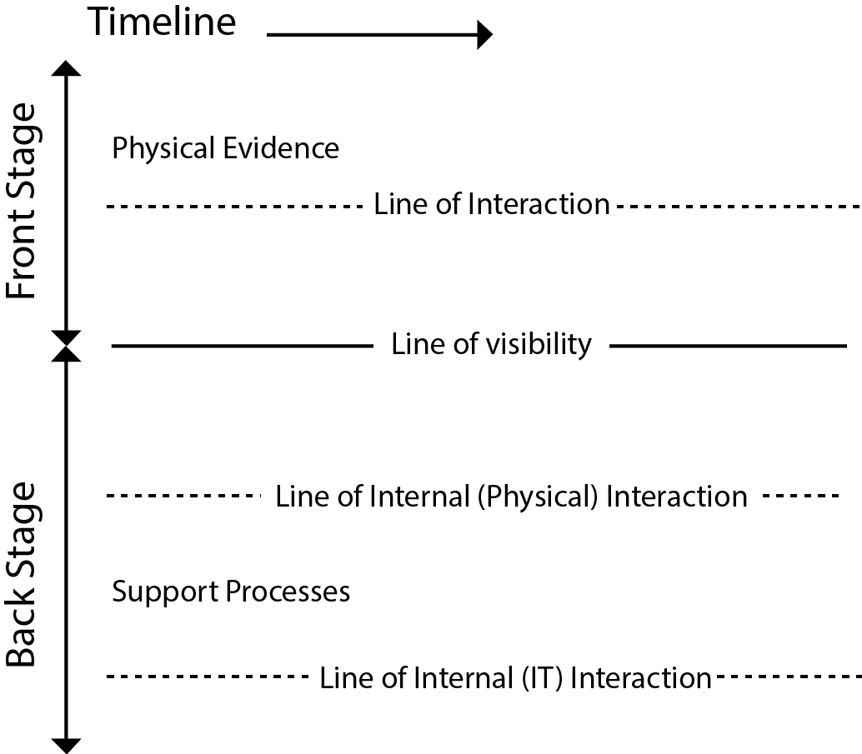

Fig. 1 Service Blueprint development components

III. Research Methods

A. Research methods

The research design involved the followings stages: (1)Problem findings and background research; (2) the selection of local korean restaurant and halal restaurant in Busan; (3) Comparison on both restaurants’ service process from arrival of the restaurant until leaving the restaurant; (4) Service blueprint created and similarities and difference touchpoints being analyzed; (5) Propose hypotheses for halalize local korean restaurant by applied the different touchpoints service; (6) Evaluation and validation; (7) Proposed final Optimized Halal Korean Restaurant Service Process. (Table 7)

TABLE 7
Research design stages

Step 1 | Problem findings + Background research
Step 2 | Local korean restaurant (Cheong-a-deh) + Halal restaurant (Morocco Casablanca Restaurant Halal Food) being selected
Step 3 | Comparison on both restaurants’ service process from arrival until leaving
Step 4 | Portrayed service in Service Blueprint and similarities and differences being analyzed
Step 5 | Hypothesis statements proposed for certified Korean halal restaurant
Step 6 | General Customer satisfaction survey and Kano Model Survey
Step 7 | Proposed an optimization of halalizing Korean restaurant service processes model
B. Research target

It is important to consider that a service blueprint is valid for only one target group. For multiple target groups, the optimal service processes are often dissimilar. [9] Therefore, in the research, researcher only focus on a local Korean restaurant and a halal restaurant in Busan. Local Korean restaurant (Cheong-a-deh) located at Naengjeong Station being selected as it served native local specialties and distinctive styles within Korean cuisine. Halal food is difficult to be found in Busan thus finding the Busan Masjid is the key to find a halal restaurant in Busan. By recommended from bloggers, Morocco Casablanca Restaurant Halal Food close to the Busan Al-Fatah Masjid was an easy location and increasingly popular among Muslim diners being selected as halal restaurant target. For the sampling of questionnaires section, a total of 60 respondents (first phase) opted out in this study. Researcher will conducting second phase questionnaires and considering the limits of the questionnaire as a data collection instrument, other qualitative methods such as in depth interviews were also used in exploring the insights of this study later.

IV. Findings and discussion

A. Service Blueprint Comparison

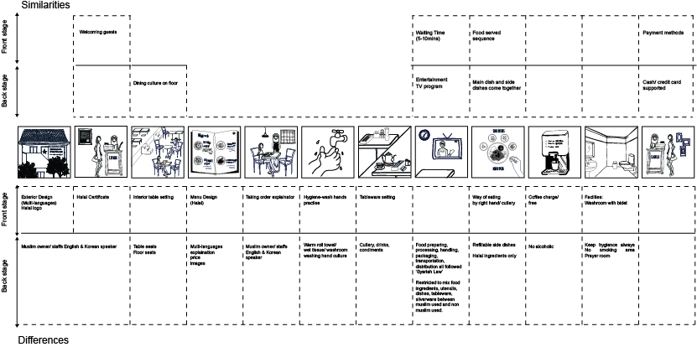

Fig. 2 Service Blueprint Analysis Comparison

By recording a service blueprint (Fig.2), the content analysis provides an overview of the visible and invisible service process in both restaurants. From the starting point since arrived at the restaurant, the exterior design with the restaurant signage can spot the differences. Local Korean restaurant (Cheong-a-deh) provided only hangul whereas halal restaurant (Morocco Casablanca Restaurant Halal Food) provided with both hangul and English languages. For Cheong-a-deh it will be a failure point which foreigners who do not know Korean languages could not understand what kinds of restaurant it is. Next, Morocco Casablanca Restaurant issued with the halal logo certification and it was an eating premises means that the restaurant, as well as the entire food supply chain, conform to Islamic dietary rules which do not tolerate contamination by haram (prohibited) materials. Halal restaurant also required workers who are Muslim in the kitchen/handling/food processing. For the interior of table seating, Cheong-a-deh provided with two types of table setting which is floor seat and table seat. It could be a reference for halal restaurant to apply on as tourist would like to experience Korean dining culture as well. For further understanding that Muslim also has the floor seated dining etiquette from the past. Besides that, menu design will be another important feature to be focus on as tourist usually would not understand the menu if they only provided with the Korean language. Through observation, menu design should be included with images, price, and food explanation in both Korean and English language. Indeed workers in the restaurant whoever able to speak both languages would be preferable. Tableware setting is partially different as the food consumption method was different too. Because of Muslim dining etiquette, the hands should be washed before the mea and after meals. Food should always be eaten with the right hand, preferably using the first three fingers. Therefore, wet tissue or warm rolled towel provided in halal restaurant is a must or it can be given attention on hygiene in the washroom. Entertainment service such as television is basically similar in both restaurants. Refillable side dishes and free coffee consumption in local Korean restaurant will be a highlight among the tourists. Other than local tea and water, others beverages will be charges accordingly in Morroco Casanblanca Rrestaurant. Another important findings in halal restaurant is water-usage friendly washrooms. This entails the use of water in the toilets, and it is discomforting for Muslim travelers where the setup for water use is not available. Availability of hand showers, bidets or even Japanese-style toilets will be able to solved the discomfortness. Prayer facilities service will enhance the Islamic infrastructure for Muslim travellers and avoid facilities that serve alcohol or haram activities in the restaurant. Lastly, payment service was similar in both restaurants.

B. Keywords derived and generating hypotheses

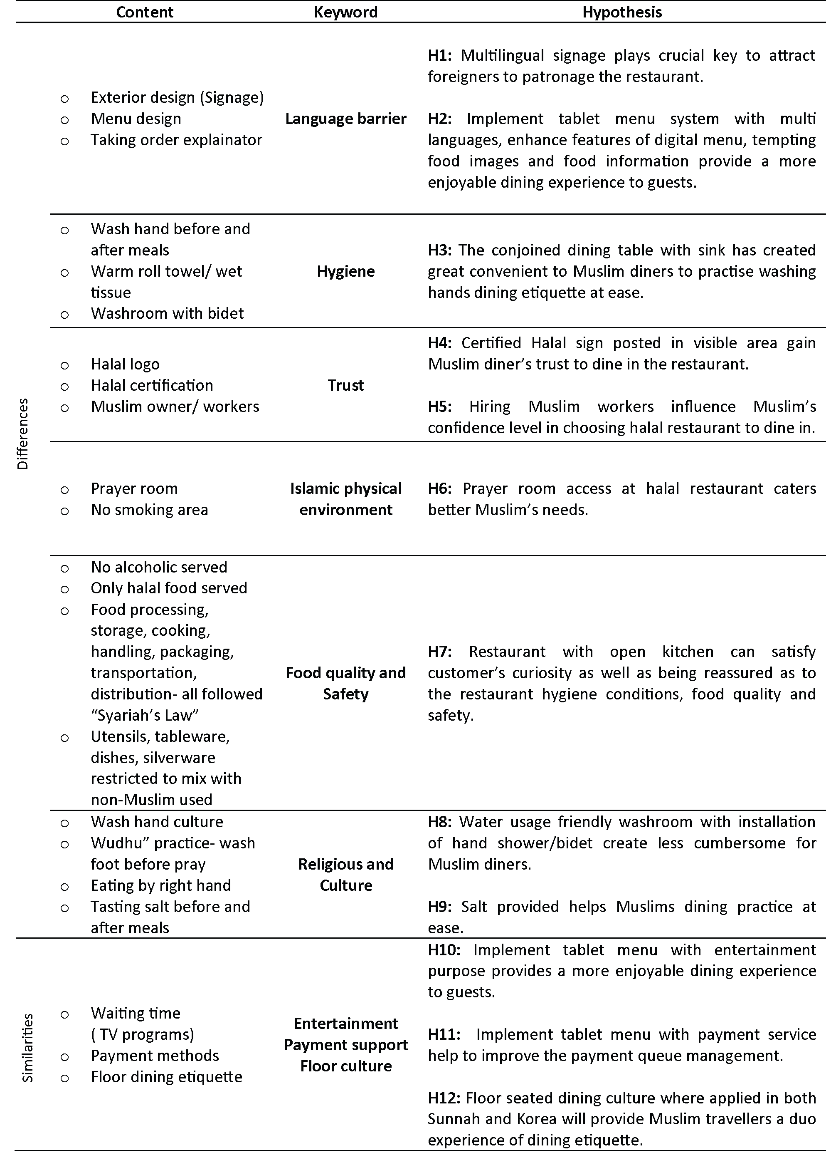
Fig. 3 Deriving keywords and hypotheses development
Refer to the (Fig.3), Significant keywords were derived from the difference and similarities of service contents. Language barrier, Hygiene, Trust, Islamic physical environment, Food quality and safety, Religious and Culture, Entertainment, Payment Support and Floor culture are the essential keywords for the service process in both restaurants. The use of keywords provide the direction to purpose of generating hypotheses.

C. Data Analysis

To test the hypotheses, this study utilized a general customer satisfaction questionnaire and KANO model. Kano’s model can help the decision-maker value the service features from customers’ viewpoints in multiple dimension. The merit of using a Kano evaluator, which leverages upon both the customer's satisfaction and the producer's capacity.
As presented in Table 8, respondents were from different age groups, duration of staying, purpose of visiting, experience to visit korean restaurant and halal restaurant in South Korea which provided some rich and unique findings in the context of this study.

TABLE 8
Demographic

Demographic variables | Categories | Frequency |  | Percentage
Nationality | Indonesia |  | 22 |  | 36.6%
 | Malaysia |  | 14 |  | 23.3%
 | Singapore |  | 8 |  | 13.3%
 | Iraq |  | 3 |  | 5.0%
 | Morocco |  | 2 |  | 3.3%
 | Pakistan |  | 2 |  | 3.3%
 | Uzbekistan |  | 2 |  | 3.3%
 | Egypt |  | 1 |  | 1.7%
 | Gambia |  | 1 |  | 1.7%
 | Kazakhstan |  | 1 |  | 1.7%
 | Sudan |  | 1 |  | 1.7%
 | Turkmenistan |  | 1 |  | 1.7%
 | Bangladesh |  | 1 |  | 1.7%
 | Iran |  | 1 |  | 1.7%
 | Total |  | 60 |  | 100
Age group | 20 below |  | 2 |  | 3.3%
 | 21-30 |  | 39 |  | 65%
 | 31-40 |  | 12 |  | 20%
 | 41-50 and above |  | 7 |  | 11.7%
How long have you been staying in South Korea | Less than a week  Less than a month  Less than a year  More than a year and above |  | 14  10  8  28 |  | 23.3%  16.7%  13.3%  46.7%
Purpose of visiting South Korea | Tourist  Foreign Student  Resident  Businessman  Employee |  | 22  36  0  1  1 |  | 36.7%  60.0%  0%  1.7%  1.7%
Have you ever been to Korean restaurant in South Korea | Yes  No |  | 58  2 |  | 96.7%  3.3%
If yes, how frequently did you visit Korean restaurant | Once a month or less  Once a week  2/3 times a week  More than once a week |  | 14  11  8  25 |  | 24.1%  19.0%  13.8%  43.1%
Have you ever been to halal restaurant in South Korea | Yes  No |  | 56  4 |  | 93.3%  6.7%
If yes, how frequently did you visit halal restaurant | Once a month or less  Once a week  2/3 times a month  More than once a week |  | 27  6  11  12 |  | 48.2%  10.7%  19.6%  21.0%
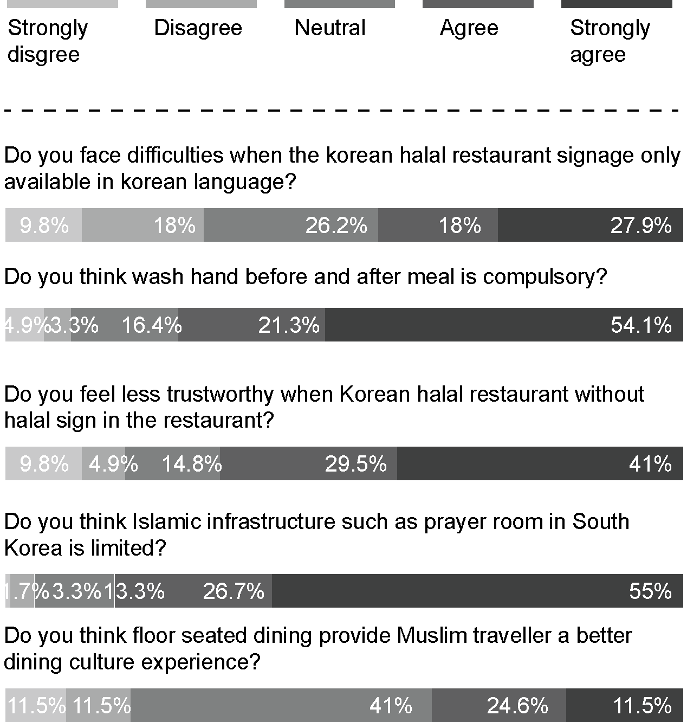

Fig. 4 General Customer satisfaction Survey

Figure 4 shows the general survey of customer satisfaction according to the questions. Based on the results, 45.9% respondents agreed that they were facing difficulties when the Korean halal signage only available in Korean language. These value indicated that as a tourist who do not know Korean language it could be a language barrier for them to patronage a restaurant. From the perspective of Muslim dining etiquette, cleanliness and hygiene in Islam are emphasized to the extent Prophet Muhammad. The practice of washing hands before and after meals is strongly emphasized from the respondents with 75.4% agreed with it. At the same time, 70.5% respondents agreed with that Korean halal restaurant without any halal sign will create less trustworthy on the restaurant. Prayer is the method of worship and the main connection of man to Allah (God) and is considered to be the most important obligation and duty of a Muslim. Every Muslim is expected to pray five times a day and not praying is not an option. However Muslims do have the option of shortening and combining prayers when travelling in South Korea. 81.7% of respondents agreed and relected that South Korea is paucity of Islamic infrastructure such as prayer room. Lastly, 36.1% of respondents agreed that floor seated dining provide Muslim traveller a better dining culture experience in South Korea.

D. Kano Model Analysis

The Kano model is a theory of product development and customer satisfaction developed in the 1980s by Professor Noriaki Kano, which classifies customer preferences into five categories as shown in Table 9. [12]

TABLE 10
Kano Model Categories

Kano Classification | Definition
Attractive Quality | These attributes provide satisfaction when achieved fully, but do not cause dissatisfaction when not fulfilled.
Expected Quality | These attributes are taken for granted when fulfilled but result in dissatisfaction when not fulfilled.
One-dimensional Quality | These attributes result in satisfaction when fulfilled and dissatisfaction when not fulfilled.
Indifferent Quality | These attributes refer to aspects that are neither good nor bad, and they do not result in either customer satisfaction or customer dissatisfaction.
Reverse Quality | These attributes refer to a high degree of achievement resulting in dissatisfaction and to the fact that not all customers are alike.

Kano survey is carried out within speciﬁc market segments that consist of customers with similar demographic information from above. From the Fig. 5, customer perception can be explicitly measured into different types of categories from customer satisfaction and dissatisfaction with respect to a combination of service features. Based on the result in Table 10, from the customer’s perspective, implemented table menu system with enhanced features will provide satisfaction when achieved fully, which is an attractive quality to the guests. Hypotheis 2 is accepted. Besides that, certified halal sign indicate a trust for the diner and it can be attractive quality if the halal sign is posted in a visbible area. Hypothesis 4 is accepted. Hiring Muslim workers can be an attractive quality for Muslim diner as it is help them to build confidence on the particular halal restaurant. Hypothesis 5 is accepted. As mentioned in the general survey, prayer practices of islam is considered to be the most important obligation and duty of a Muslim, the coefficient of satisfaction, 0.72 indicated that halal restaurant provided with prayer room accesss will be a great satisfaction among the Muslim diners. Hypothesis 6 is accepted. Lastly, for Muslims, water plays a key role in purity and cleanliness, special attention is given to hygiene in the washroom. Hand shower or bidet is another practical feature of a washroom that serves to wash oneself after using the toilet by Muslim. Therefore, if water-friendly washroom is applied in Korean halal restaurant, it will be another attractive quality among the Muslim. Hypothesis 8 is accepted.

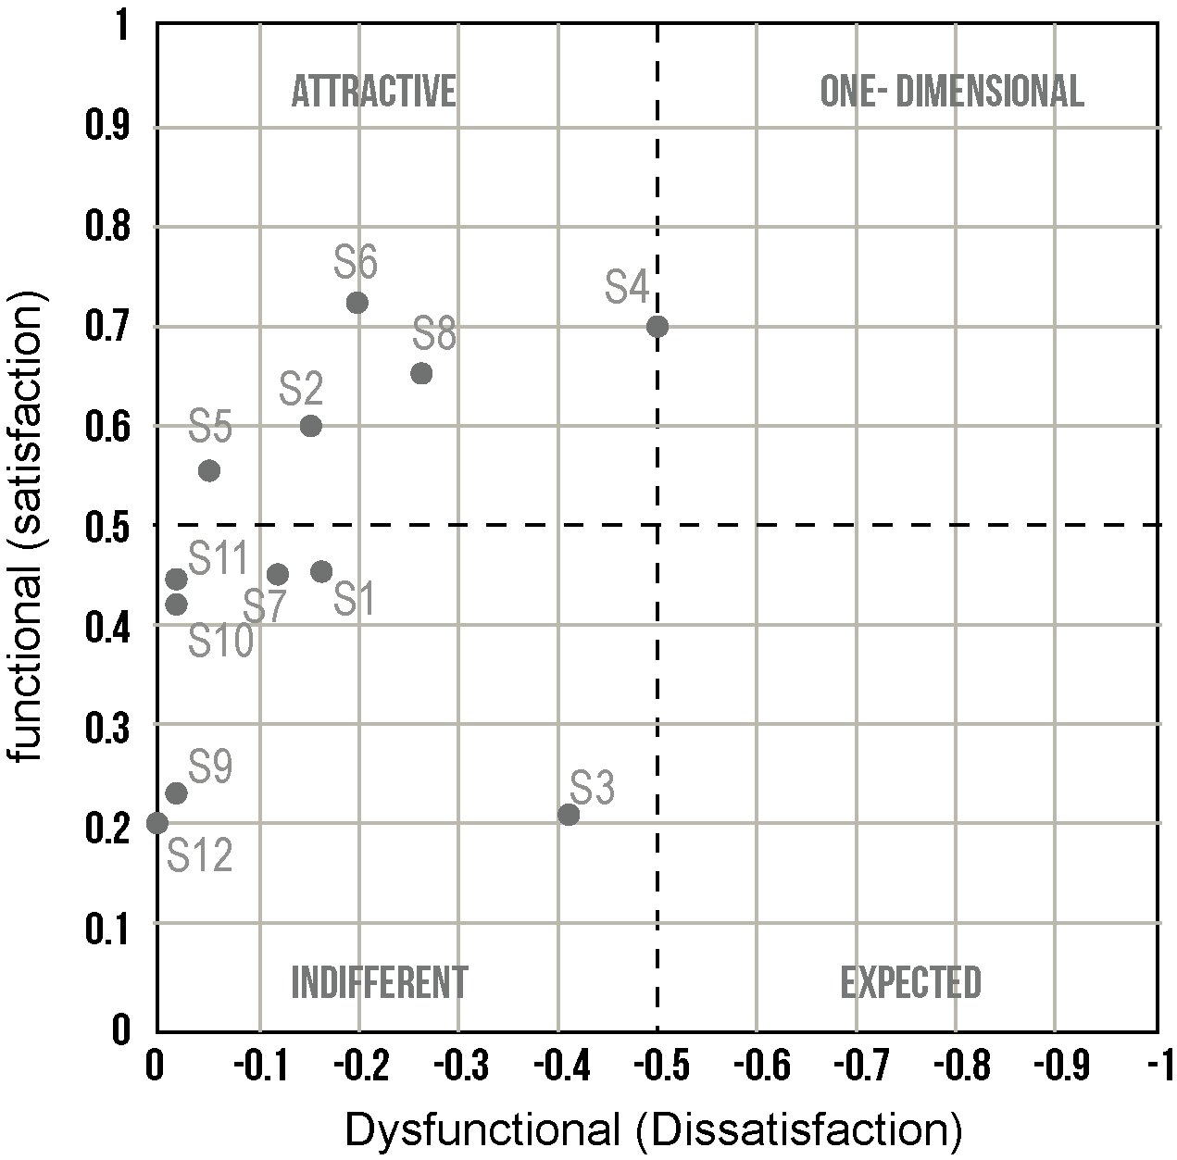
Fig. 5 Coefficient of customer satisfaction and dissatisfaction

TABLE 10
Kano Model Analysis

Service Features | Kano Classification | Coefficient of Satisfaction | Coefficient of Dissatisfaction
S2. If tablet menu (multi languages, food images, food information) is implemented in Korean halal restaurant. How do you feel? | Attractive Quality | 0.60 | -0.15
S4. If certified halal sign is posted in a visible area in Korean halal restaurant. How do you feel? | Attractive Quality | 0.70 | -0.50
S5. If Muslim workers are hired in Korean halal restaurant. How do you feel? | Attractive Quality | 0.55 | -0.05
S6. If prayer room service is provided in Korean halal restaurant. How do you feel? | Attractive Quality | 0.72 | -0.20
S8. If water-friendly washroom is applied in Korean halal restaurant. How do you feel? | Attractive Quality | 0.65 | -0.26

V. Conclusion

The rise of the Muslim traveler has made the travel industry sit up and pay careful attention to meeting the needs of the Muslim travelers. Halal food to be a very important consideration for the Muslim traveler. Many destinations across the world have identified this potential and are adapting their offerings to better appeal to the Muslim travel market. Many of the Muslim tourists surveyed and interviewed for this study indicated Halal food as their primary concern when traveling. Most OIC member states have Halal certification bodies. However, their focus is on certifying products and not restaurants.[7] Thus, this study contributes to and extends our understanding of service process in the halal restaurant, South Korea and propose an optimization of halalizing Korean restaurant service processes model.

The result from the data analysis indicated that to halalize Korean restaurant into Korean halal restaurant comprised of sevral service features such as implementation of tablet menu system, certified halal sign posted in visible area, hiring Muslim workers, prayer room accessibility, and water friendly washroom. All of the features have moderate high coefficient of satisfaction with attractive quality in Kano analaysis. Therefore, researcher proposed an optimized of halalizing Korean restaurant service processes model in Fig.6. From a managerial viewpoint, the findings provide support for service provider who invest on halalize Korean restaurant into certified halal restaurant in South Korea. Besides that, it can be a guideline for the service provider and tourism industry in the future in order to remain competitive and ensure what it offers fulfils the global demand of the Muslim tourism industry.

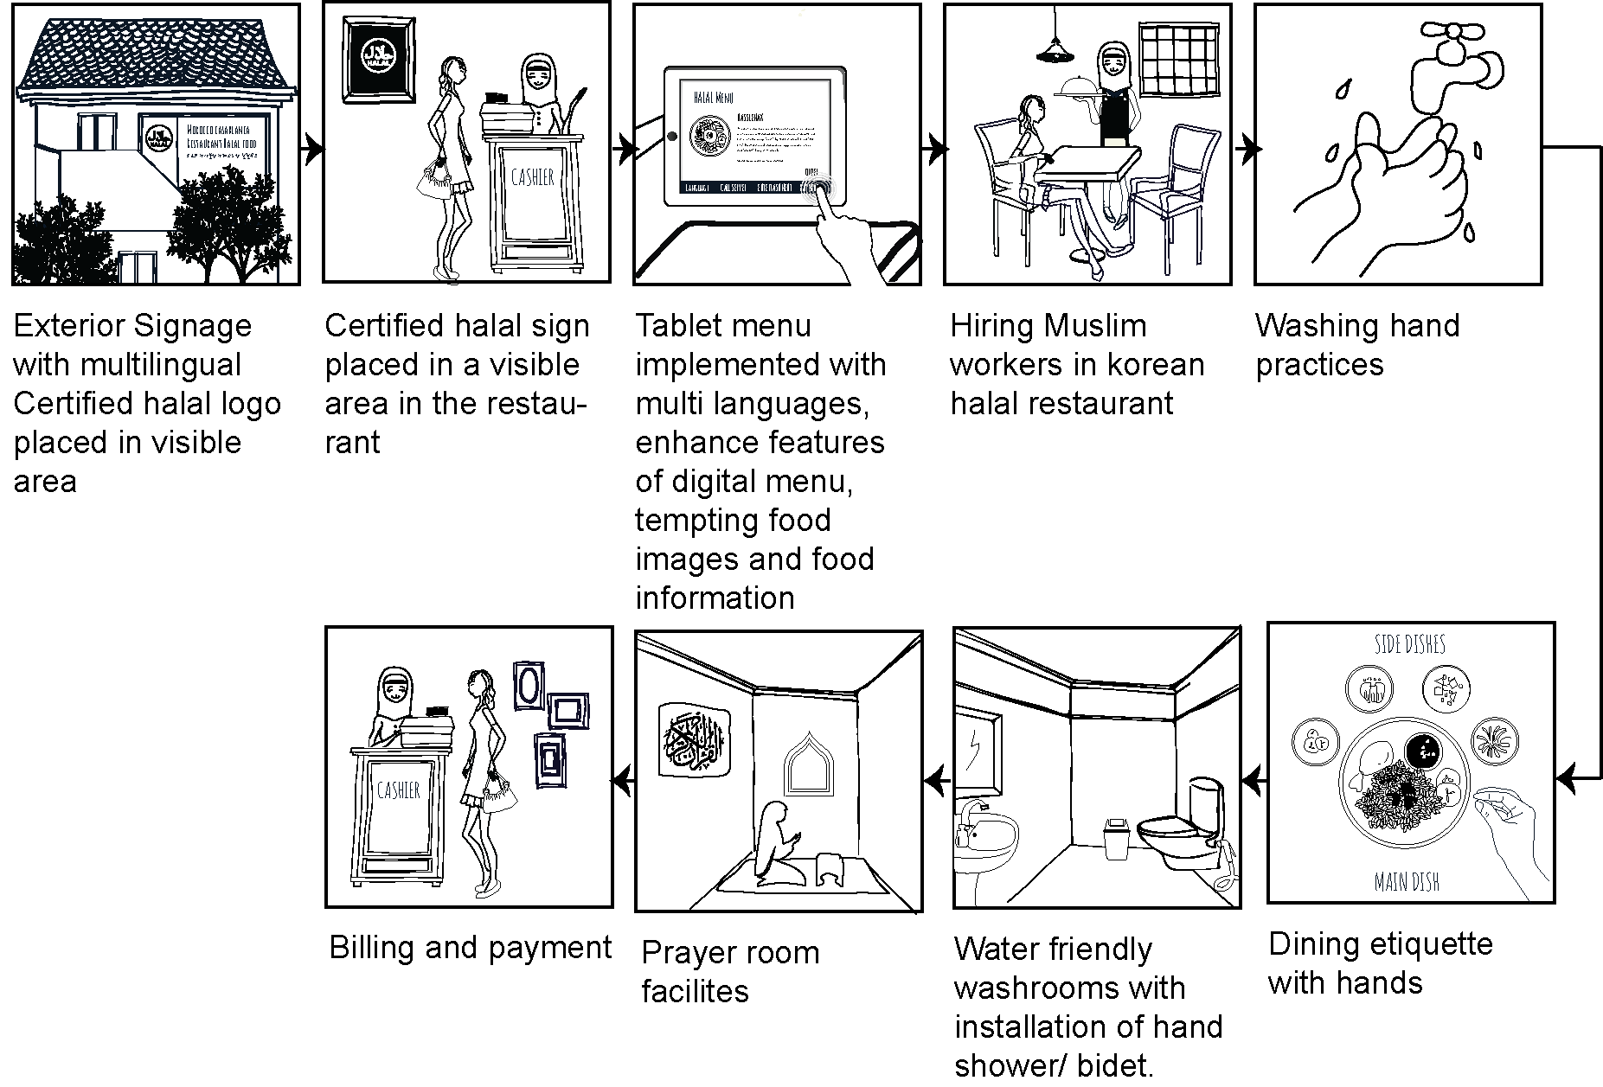

Fig. 6 An optimized of halalizing Korean restaurant service processes model

This study has a weakness that should be pointed out. With a majority sampling from foreign student’s point of view, although it may be desirable for reducing extraneous variance, limited the generalizability of the study findings. Thus, for the second phase of data collection, research intents to more focus on tourist’s perspective.

References

[1] Ministry of Culture, Sports and Tourism, Status of Muslim travellers visit South Korea, in press, 2015.
- Global Muslim Travel Index (GMTI), MasterCard-Crescent Rating Global Muslim Travel Index, 2016.
- Bessière J, Local development and heritage: traditional food and cuisine as tourist attractions in rural areas, Sociologia ruralis. 1998 Apr 1;38(1):21-34.
- Cohen E, Avieli N, Food in tourism: Attraction and impediment. Annals of tourism Research, 2004 Oct 31;31(4):755-78.
- Santich, B, Hospitality and Gastronomy: Natural Allies. In C. Lashley, P. Lynch & A. Morrison (Eds.), Hospitality: A Social Lens , London: Elsevier, 2007, pp. 47-59.
- COMCEC, Muslim friendly tourism (online), http://www.comcec.org, COMCEC Coordination Office, February 2016.
- Hassan W, Melissa W, Awang KW. Halal food in New Zealand restaurants: an exploratory study. International Journal of Economics and Management. 2009;3(2):385-402.
- Zhanglei, Sung Pil Lee, Re-establishing the public confidence of the seafood through service blueprint study. Korea Society of Industrial Design. 2014;8(4).
- Seyring M, Dornberger U, Suvelza A, Byrnes T. Service blueprinting handbook. International SEPT Program. University of Leipzig. 2009.
- Shahin A. Service Blueprinting: An Effective Approach for Targeting Critical Service Processes–With a Case Study in a Four-Star International Hotel. Journal of Management Research. 2010 May 23;2(2).
- C. Lovelock. (1996). Service Marketing. Prentice Hall. London.
- Kano, Noriaki; Nobuhiku Seraku; Fumio Takahashi; Shinichi Tsuji (April 1984). "Attractive quality and must-be quality". Journal of the Japanese Society for Quality Control (in Japanese). 14 (2): 39–48. ISSN 0386-8230.

